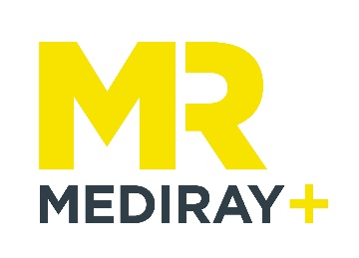
PerkinElmer Western Blotting Reagents - Buy 1 Get 1 Free Claim Form

Thank you for purchasing your western blot reagents with Mediray. Please fill out all the fields below and send through to info@mediray.co.nz to claim your free reagent!

Full Name:
Email:
Phone:
Organisation (please also include location if your organisation has multiple sites):
PO number (if available):
Desired Reagent:
Desired Free Reagent:

Terms and Conditions
- Offer is valid on new orders only and may not be applied to existing, pending or prior orders.
- Offer is valid until Dec 30, 2019.
- Free reagent must be of the same or lesser value to purchased reagent.
- This promotion may not be combined or used in conjunction with any other discounts, offers, or promotions, including discounted prices negotiated by contract or pricing schedule.
- Offer is subject to Mediray's Terms & Conditions of Sale.
- Mediray reserves the right in its sole discretion to change the terms of or discontinue
- All information submitted to Mediray in connection with this promotion will be treated in accordance with Mediray's privacy policy, available here.

