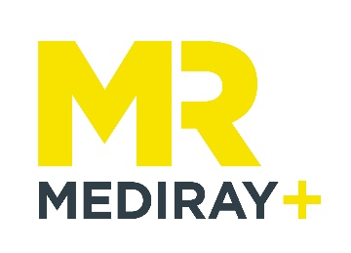
Buy 4 Get The 5th Box Free – Consumables Promotion

Thank you for purchasing your Eppendorf consumables with Mediray. Please fill out all the fields below and send through to info@mediray.co.nz to claim your free box of consumables!

Full Name:
Email:
Phone:
Organisation
Address:
City
Post Code
Goods supplied
Goods claimed

